

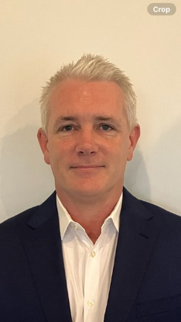

**Matthew Hogan  
Development Director, Innovation Districts and City  
Renewal SA**

Matt is the Development Director, Innovation Districts and City at Renewal SA with more than 20 years of experience in property and civil construction, specialising in leading diverse multi-disciplinary teams to deliver complex high value property and infrastructure projects. Matt joined Renewal SA in 2023 and brings his property and project management expertise, stakeholder centric focus and knowledge of machinery of government to deliver major property development projects to benefit all South Australians through the creation of infrastructure and built form that supports vibrant and collaborative communities, opportunities for new and emerging businesses, boosting economic benefit to build the state’s sovereign capabilities and position South Australia on the global innovation market. Matt’s current portfolio includes the innovation districts of Tonsley and Lot Fourteen, as well as the development of the vibrant Festival Plaza business, social and arts precinct.